Module 1: Abstract Data Types
Contents
- Abstract Data Type (ADT) 1
- Concrete State Space 2
- Concrete Invariant 2
- Abstraction Function 2
- Abstract Class 3
- Abstract Method 3
- Abstract Keyword 4
- Interfaces 4
- Interface vs Abstract class 5
- Binding 6
- Association, Aggregation, Composition 8

Abstract Data Type (ADT)
- An ADT is a mathematical model in data types, that defines a data type by its behavior from the point of view of a user, specifically in terms of the operations that can be performed on it and the mathematical properties of those operations.
- ADTs are abstract because they focus on what the data represents and what operations are available, rather than how these operations are implemented.
- Examples of ADTs: Common examples include stacks, queues, lists, and trees

  - Implementation of ADTs
    - Array ADT
- Access an element: Retrieve an element at a specific index.
- Update an element: Change the value of an element at a specific index.
- Length: Retrieve the number of elements in the array.
- Insert an element: Add an element at a specific position (in the case of dynamic arrays).
- Delete an element: Remove an element at a specific position (in the case of dynamic arrays).

    - Stack ADT
- push(element): Adds an element to the top of the stack.
- pop(): Removes and returns the top element of the stack.
- peek(): Returns the top element without removing it.
- isEmpty(): Checks if the stack is empty.

    - Queue ADT
- enqueue(element): Adds an element to the end of the queue.
- dequeue(): Removes and returns the element at the front of the queue.
- peek(): Returns the element at the front without removing it.
- isEmpty(): Checks if the queue is empty.

    - Tree ADT (Binary Tree):
- insert(element): Adds an element to the tree.
- find(element): Searches for an element in the tree.
- traverse(): Visits all elements of the tree in a specific order (e.g., in-order, pre-order, post-order).
- delete(element): Removes an element from the tree.

Concrete State Space
The concrete state space of an ADT implementation refers to the actual data structure and variables used to represent the ADT in memory. It is the set of all possible configurations or values of the data structures that the ADT can hold. Example: For a stack implemented using an array, the concrete state space includes:
- The array that stores the elements.
- A variable (e.g., topIndex) that tracks the index of the top element in the stack.
- The size of the array (capacity).

Concrete Invariant
A concrete invariant is a condition or set of conditions that must always hold true for the concrete state space of an ADT implementation. It defines the rules that ensure the data structure remains valid and consistent throughout its operations. Example: For the same stack example, the concrete invariants might be:
  - topIndex >= -1 (the top index is at least -1, indicating an empty stack if it's -1).
  - topIndex < capacity (the top index is always within the bounds of the array).
  - The array elements from 0 to topIndex are the elements currently in the stack, while elements beyond topIndex are irrelevant or uninitialized.
Importance of Concrete Invariants
- Ensure Consistency: They guarantee that the ADT behaves as expected, regardless of the operations performed on it.
- Facilitate Debugging: By providing a set of conditions that must always be met, invariants help identify when and where an implementation may be failing.
- Assist in Verification: Invariants are used in formal verification methods to prove that an ADT implementation correctly implements its specification.

Abstraction Function
The abstraction function is a crucial concept in the design and implementation of Abstract Data Types (ADTs). It is a way of mapping the concrete representation of an ADT (i.e., the actual data structure and its state in the program) to the abstract view or model of the data type. This mapping helps in reasoning about the correctness and behavior of the ADT by abstracting away the implementation details. Example: Stack ADT
Concrete Representation:
- An array stack[] holding the elements.
- An integer topIndex indicating the index of the top element.
Abstract Model: A sequence of elements where elements are added and removed in a last-in-first-out (LIFO) manner.
Abstraction Function:
  - AF(stack, topIndex) = [stack[0], stack[1], ..., stack[topIndex]] if topIndex >= 0
  - AF(stack, topIndex) = [] if topIndex == -1

Abstract Class
An abstract class is a class that cannot be instantiated on its own and is meant to be subclassed. It can contain both abstract methods (methods without a body) and concrete methods (methods with an implementation). Characteristics:
  - Defined using the abstract keyword.
  - Cannot be instantiated directly (e.g., new AbstractClass() is not allowed).
  - Can contain abstract methods, concrete methods, fields, and constructors.
  - Used to provide a base for subclasses to implement specific behavior.
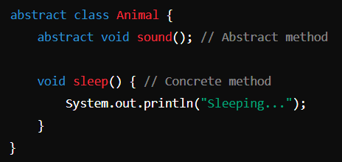

Abstract Method
An abstract method is a method that is declared without an implementation (no body) and must be implemented by any concrete subclass of the abstract class. Characteristics:
  - Defined using the abstract keyword.
  - Has no body; subclasses must provide an implementation.
  - Can only exist in abstract classes or interfaces.
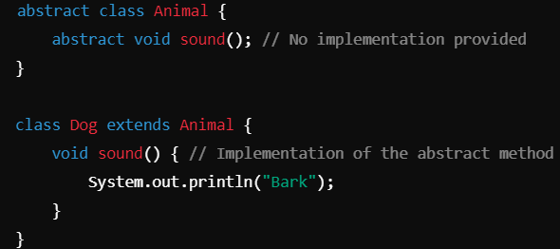

Abstract Keyword
The abstract keyword is used to declare both abstract classes and methods. It signifies that the class or method is incomplete and that it should be further defined by subclasses. Usage:
  - For abstract classes: To indicate that the class cannot be instantiated and may contain abstract methods.
  - For abstract methods: To indicate that the method must be implemented by subclasses.

Interfaces
In Java, an interface is a reference type that is like a class but can only contain method signatures and constant declarations. Interfaces are a core part of Java’s object-oriented programming (OOP) paradigm and provide a way to achieve abstraction and multiple inheritance. Key Features:
- Abstract Methods:
  - All methods in an interface are abstract by default (i.e., they do not have a body). Classes that implement the interface must provide implementations for these methods.
  - Since Java 8, interfaces can also contain default methods (with a body) and static methods.
- Constant Declarations: Interfaces can declare constants, which are implicitly public, static, and final.
- Multiple Inheritance: A class can implement multiple interfaces, allowing Java to achieve multiple inheritance. This is not possible with classes, as Java does not support multiple inheritance for classes to avoid ambiguity.
- Interface Declaration:
  - An interface is declared using the interface keyword.
  - Interfaces can extend other interfaces, allowing for a hierarchical structure.
Interface Declaration
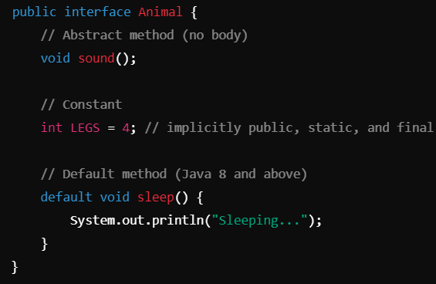

Implementing an Interface
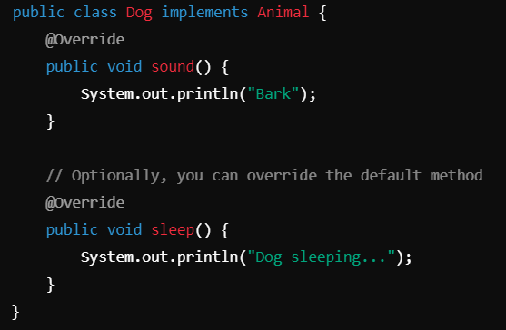
Advantages of Interfaces
- Abstraction: Interfaces allow you to define a contract that implementing classes must adhere to, providing a clear separation between the specification and implementation.
- Multiple Inheritance: Java allows a class to implement multiple interfaces, enabling a class to inherit behaviors from multiple sources.
- Flexibility: Interfaces enable you to easily swap implementations without changing the code that uses the interface.
- Polymorphism: Interfaces support polymorphic behavior, allowing you to write more generic and reusable code.

Interface vs Abstract class
Aspect | Interface | Abstract Class
Definition | A reference type in Java that can contain constants, method signatures, and default methods. It is a contract that classes must adhere to. | A class that cannot be instantiated and can have abstract methods (without a body) as well as concrete methods (with a body).
Inheritance | Supports multiple inheritance (a class can implement multiple interfaces). | Supports single inheritance (a class can extend only one abstract class).
Method Implementation | Methods are abstract by default (until Java 8 introduced default methods), and cannot have any implementation (except default and static methods). | Can have both abstract methods (without implementation) and concrete methods (with implementation).
Access Modifiers | All methods in an interface are implicitly public and abstract (except static and default methods). | Can have various access modifiers (public, protected, private) for its methods and fields.
Fields | All fields in an interface are implicitly public, static, and final (constants). | Can have instance variables that can be any access modifier (public, protected, private) and can be mutable.
Use Case | Ideal for defining a contract for unrelated classes or behaviors, where multiple classes can implement the same set of methods. | Suitable for providing a common base for related classes with shared behavior and state.
Instantiation | Cannot be instantiated directly; must be implemented by a class. | Cannot be instantiated directly; must be subclassed by a concrete class.
Default Methods | Supports default methods (since Java 8), allowing the interface to provide a default implementation. | Does not support default methods; all methods must be implemented by subclasses unless declared abstract.
Polymorphism | Allows polymorphism through implementation of interfaces. | Allows polymorphism through inheritance of abstract classes.
Example | java<br>interface Animal {<br> void makeSound();<br>} | java<br>abstract class Animal {<br> abstract void makeSound();<br> void sleep() {<br> // implementation<br>}<br>}

Binding
In Java, binding refers to the linking of a method call to the method body. Binding can be categorized into two types: static binding (or early binding) and dynamic binding (or late binding). Types:
1. Static Binding (Early Binding): Static binding occurs at compile time. The method to be called is determined based on the reference type (not the object type). This is typically seen with:
  - Final methods: Methods marked as final cannot be overridden, so the compiler knows which method to call at compile time.
  - Static methods: Similar to final methods, static methods belong to the class, not to instances of the class.
  - Private methods: These methods cannot be accessed from outside their class, so their binding is resolved at compile time.
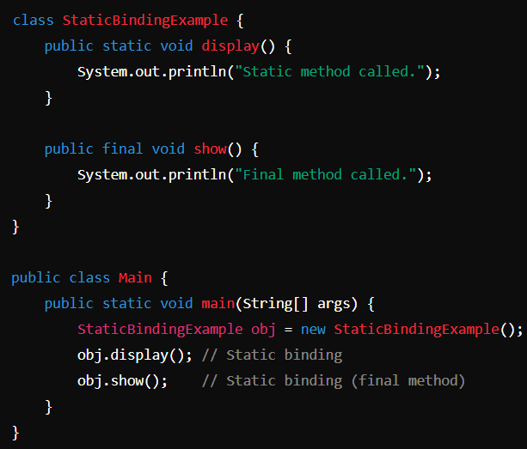
2. Dynamic Binding (Late Binding): Dynamic binding occurs at runtime. The method that is called is determined based on the actual object that the reference points to, not the reference type. This allows for polymorphism, enabling method overriding in subclasses.
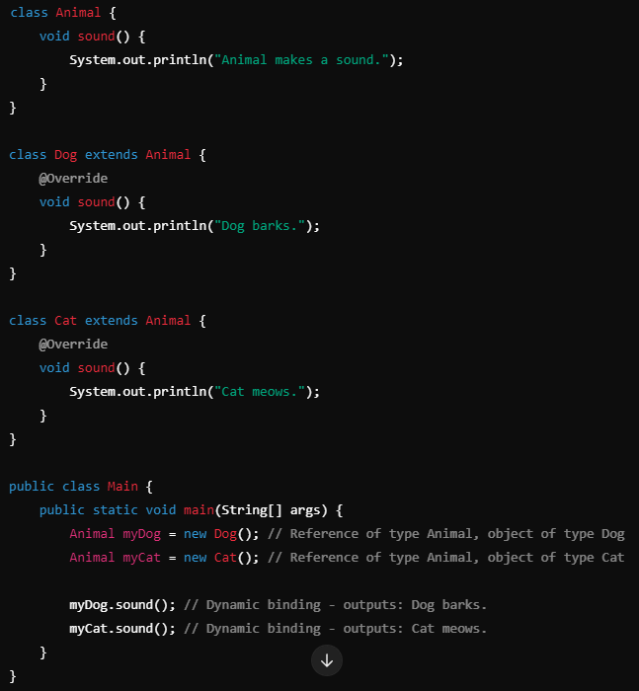Key Differences
Feature | Static Binding | Dynamic Binding
Time of Binding | Compile time | Runtime
Method Resolution | Based on reference type | Based on object type
Usage | Final, static, and private methods | Overriding methods in inheritance
Polymorphism | Not applicable | Supports polymorphism

Association, Aggregation, Composition
In Java Object-Oriented Programming (OOP), association, aggregation, and composition represent different types of relationships between classes.
1. Association: A general relationship between two classes where one class uses or interacts with another class. Example: A Teacher class and a Student class have an association because teachers teach students, but both can exist independently.
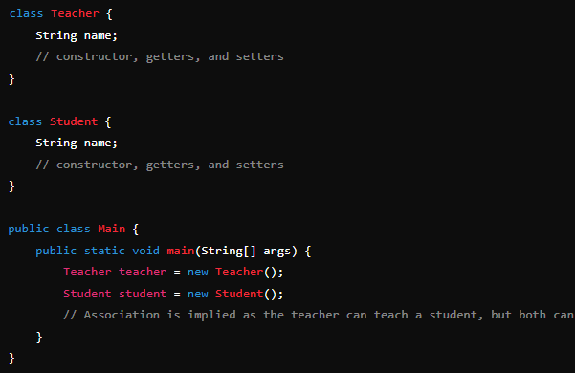
// Association is implied as the teacher can teach a student, but both can exist separately.
2. Aggregation: A specialized form of association where one class (the whole) contains a reference to another class (the part), but the part can exist independently of the whole. Example: A Department class and a Professor class where Department aggregates Professor. A professor can exist even if the department is dissolved.
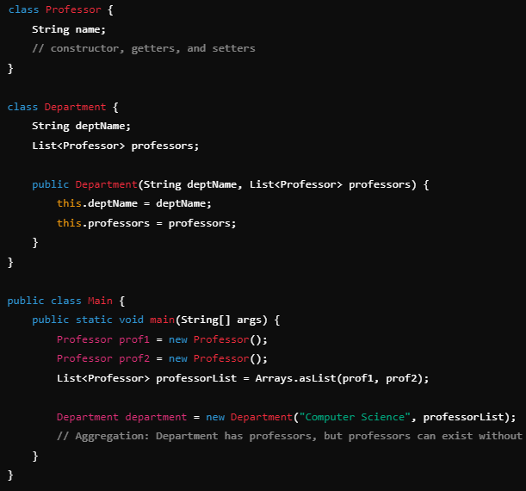
// Aggregation: Department has professors, but professors can exist without the department.
3. Composition: A stronger relationship than aggregation where one class (the whole) owns another class (the part), and the part cannot exist without the whole. If the whole is destroyed, the part is also destroyed. Example: A Library class and a Book class where Library composes Book. If the library is deleted, the books in it are also deleted.
